Git Exercises Practice

1 recruit@umuzi-umuzi:~$ mkdir git_basic_exercise

2 recruit@umuzi-umuzi:~$ cd git_basic_exercise

3 recruit@umuzi-umuzi:~/git_basic_exercise$ ls -a

4 recruit@umuzi-umuzi:~/git_basic_exercise$ git init
recruit@umuzi-umuzi:~/git_basic_exercise$ ls -a
Yes there is a difference, the directory is no more empty

5 recruit@umuzi-umuzi:~/git_basic_exercise$ git status
On branch master

No commits yet

6 recruit@umuzi-umuzi:~/git_basic_exercise$ touch README.md
recruit@umuzi-umuzi:~/git_basic_exercise$ ls -a
. .. .git README.md
recruit@umuzi-umuzi:~/git_basic_exercise$ git status
On branch master

No commits yet

Untracked files:
(use "git add <file>..." to include in what will be committed)

README.md

nothing added to commit but untracked files present (use "git add" to track)

7 recruit@umuzi-umuzi:~/git_basic_exercise$ git log
fatal: your current branch 'master' does not have any commits yet

8 recruit@umuzi-umuzi:~/git_basic_exercise$ git add README.md

9 recruit@umuzi-umuzi:~/git_basic_exercise$ git status

10 recruit@umuzi-umuzi:~/git_basic_exercise$ git rm --cached README.md ==used to remove a file added by git
recruit@umuzi-umuzi:~/git_basic_exercise$ git status

11 recruit@umuzi-umuzi:~/git_basic_exercise$ git commit -m "initial commit"
[master (root-commit) d733023] initial commit
1 file changed, 0 insertions(+), 0 deletions(-)
create mode 100644 README.md

12 recruit@umuzi-umuzi:~/git_basic_exercise$ git log
commit d733023af458fd89bce0b71d0b5bfb4f5d260f22 (HEAD -> master)
Author: nonto23 <nnontokozo17@gmail.com>
Date: Fri Jan 17 09:55:26 2020 +0200

initial commit

Question 2

2.1
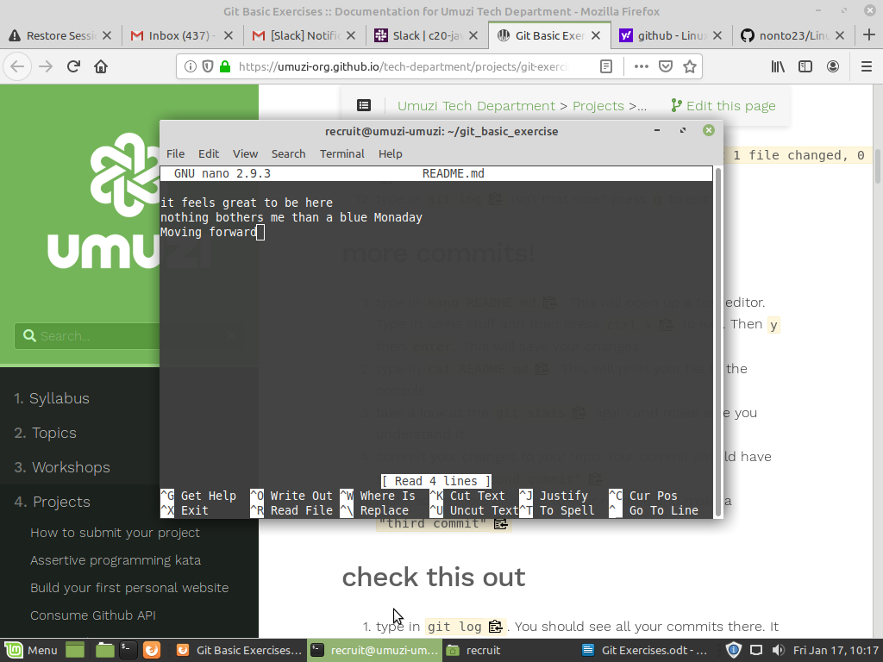
2.2 recruit@umuzi-umuzi:~/git_basic_exercise$ cat README.md
it feels great to be here
nothing bothers me than a blue Monaday
Moving forward

2.3 recruit@umuzi-umuzi:~/git_basic_exercise$ git status
On branch master
Changes not staged for commit:
(use "git add <file>..." to update what will be committed)
(use "git checkout -- <file>..." to discard changes in working directory)

modified: README.md

no changes added to

2.4 recruit@umuzi-umuzi:~/git_basic_exercise$ git commit -m "second commit"
[master e0d6645] second commit
1 file changed, 4 insertions(+)
2.5 recruit@umuzi-umuzi:~/git_basic_exercise$ git commit -m "Third commit"
[master 598013e] Third commit
1 file changed, 3 insertions(+)

Question 3

3.1 git log == is use to record all your commits
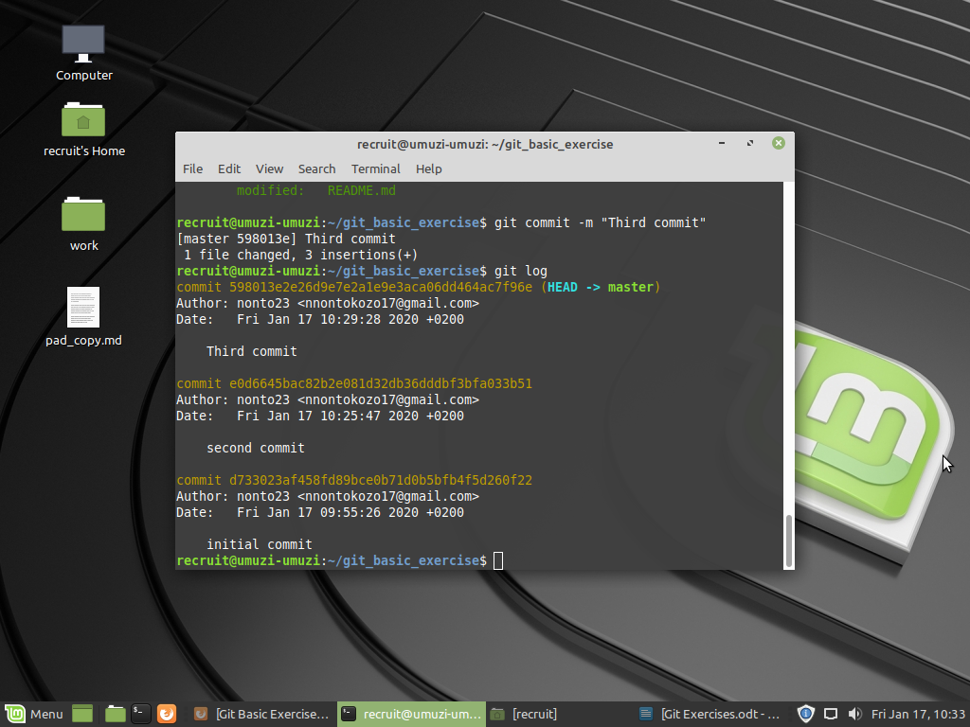
3.2

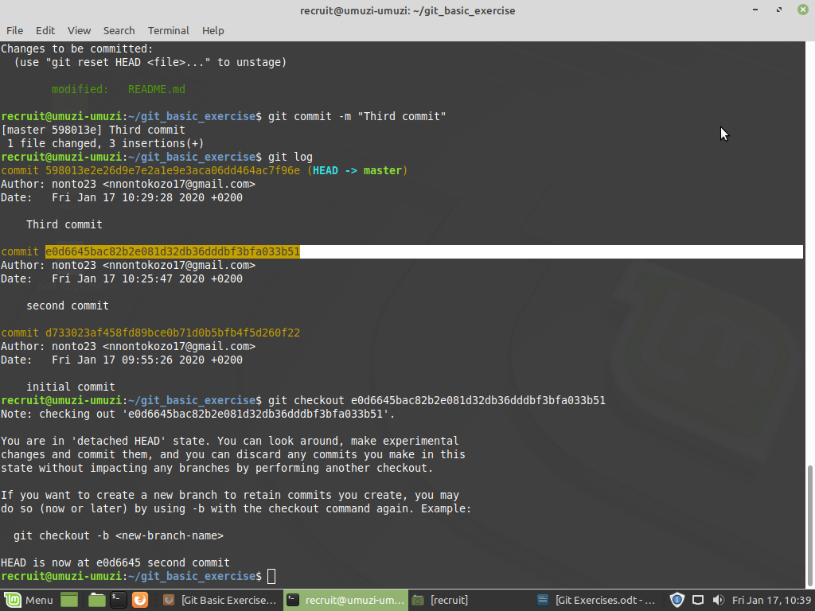
3.3

3.4 recruit@umuzi-umuzi:~/git_basic_exercise$ cat README.md
it feels great to be here
nothing bothers me than a blue Monaday
Moving forward

3.5 recruit@umuzi-umuzi:~/git_basic_exercise$ git checkout master
Previous HEAD position was e0d6645 second commit
Switched to branch 'master'

checkout command check the specific commit git and give you all thedetail

Branching

1 recruit@umuzi-umuzi:~/git_basic_exercise$ git branch == list all your branches
* master

2 recruit@umuzi-umuzi:~/git_basic_exercise$ git branch milkshake_flavours

3. recruit@umuzi-umuzi:~/git_basic_exercise$ git branch
* master
milkshake_flavours

4.
5. recruit@umuzi-umuzi:~/git_basic_exercise$ git checkout milkshake_flavours
Switched to branch 'milkshake_flavours'
recruit@umuzi-umuzi:~/git_basic_exercise$ nano milkshake.md

6 recruit@umuzi-umuzi:~/git_basic_exercise$ git status
On branch milkshake_flavours
Untracked files:
(use "git add <file>..." to include in what will be committed)

milkshake.md=======not added to the git ..it will not be committed

nothing added to commit but untracked files present (use "git add" to track)

7 recruit@umuzi-umuzi:~/git_basic_exercise$ git commit -m "Added initial flavours"[milkshake_flavours 4f7b7c6] Added initial flavours
1 file changed, 2 insertions(+)
create mode 100644 milkshake.md === it has been added to git now it will be committed

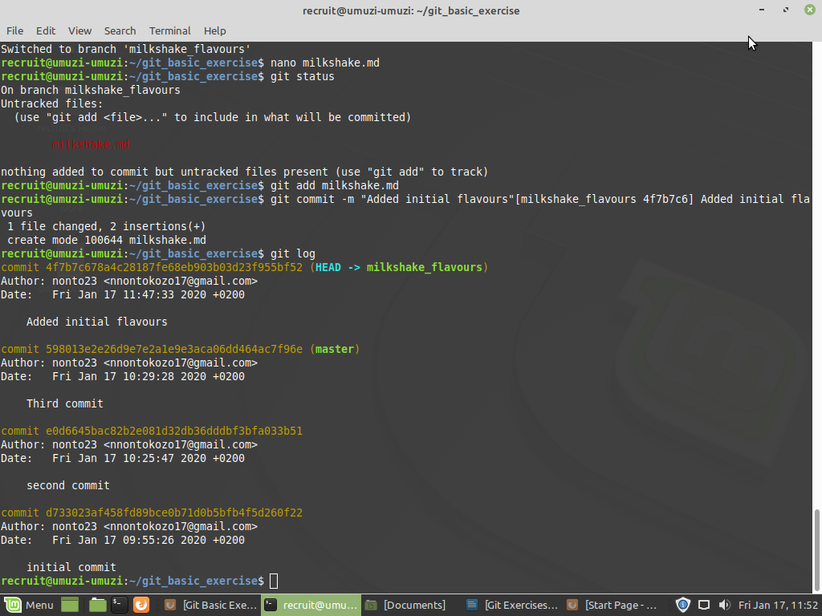
8
It does make sense . It has recorded all the commits

9 recruit@umuzi-umuzi:~/git_basic_exercise$ git checkout master

10 recruit@umuzi-umuzi:~/git_basic_exercise$ git branch history
recruit@umuzi-umuzi:~/git_basic_exercise$ git checkout history
Switched to branch 'history'
recruit@umuzi-umuzi:~/git_basic_exercise$ git log ==New branch has been created and checkout

11 recruit@umuzi-umuzi:~/git_basic_exercise$ history > history.txt

12 recruit@umuzi-umuzi:~/git_basic_exercise$ git commit -m "added history"
[history 9a4874c] added history
1 file changed, 297 insertions(+)
create mode 100644 history.txt

13 recruit@umuzi-umuzi:~/git_basic_exercise$ git checkout milkshake_flavours
Switched to branch 'milkshake_flavours'
recruit@umuzi-umuzi:~/git_basic_exercise$ git log

14 recruit@umuzi-umuzi:~/git_basic_exercise$ nano README.md
recruit@umuzi-umuzi:~/git_basic_exercise$ git add README.md
recruit@umuzi-umuzi:~/git_basic_exercise$ git status
On branch milkshake_flavours
Changes to be committed:
(use "git reset HEAD <file>..." to unstage)

modified: README.md

recruit@umuzi-umuzi:~/git_basic_exercise$ git commit -m "random readme changes"
[milkshake_flavours 81073c2] random readme changes
1 file changed, 2 insertions(+)

15 ecruit@umuzi-umuzi:~/git_basic_exercise$ git checkout history
Switched to branch 'history'
recruit@umuzi-umuzi:~/git_basic_exercise$ cat README.md

16 recruit@umuzi-umuzi:~/git_basic_exercise$ rm README.md
recruit@umuzi-umuzi:~/git_basic_exercise$ echo “booya” > README.md

17 recruit@umuzi-umuzi:~/git_basic_exercise$ git commit -m "rewrote readme"
[history b0bf104] rewrote readme
1 file changed, 1 insertion(+), 7 deletions(-)

18

Merging

1. recruit@umuzi-umuzi:~/git_basic_exercise$ git merge milkshake_flavours
Updating 598013e..81073c2
Fast-forward
README.md | 2 ++
milkshake.md | 2 ++
2 files changed, 4 insertions(+)
create mode 100644 milkshake.md
2 recruit@umuzi-umuzi:~/git_basic_exercise$ ls
milkshake.md README.md

3 recruit@umuzi-umuzi:~/git_basic_exercise$ git merge history
Auto-merging README.md
CONFLICT (content): Merge conflict in README.md
Automatic merge failed; fix conflicts and then commit the result.

4 recruit@umuzi-umuzi:~/git_basic_exercise$ ls
history.txt milkshake.md README.md
recruit@umuzi-umuzi:~/git_basic_exercise$ git log

5 recruit@umuzi-umuzi:~/git_basic_exercise$ git checkout history
README.md: needs merge
error: you need to resolve your current index first
recruit@umuzi-umuzi:~/git_basic_exercise$ git log

5.1 recruit@umuzi-umuzi:~/git_basic_exercise$ git checkout history
README.md: needs merge
error: you need to resolve your current index first
recruit@umuzi-umuzi:~/git_basic_exercise$ git merge master
error: Merging is not possible because you have unmerged files.
hint: Fix them up in the work tree, and then use 'git add/rm <file>'
hint: as appropriate to mark resolution and make a commit.
fatal: Exiting because of an unresolved conflict.

5.2

Pulling and remotes

1 recruit@umuzi-umuzi:~/git_basic_exercise$ cd ../
2
3
5 recruit@umuzi-umuzi:~$ git clone https://github.com/Umuzi-org/tech-department.git

6 recruit@umuzi-umuzi:~$ cd tech-department

7 recruit@umuzi-umuzi:~/tech-department$ git branch
* master
recruit@umuzi-umuzi:~/tech-department$ git log
commit faa2991f90c8fd5d247cdbe2300737009936f8a9 (HEAD -> master, origin/master, origin/HEAD)
Merge: 84e2c9ed 0c672dd5
Author: Sheena O'Connell <sheena.oconnell@gmail.com>
Date: Tue Jan 14 18:46:39 2020 +0200

Merge branch 'master' of github.com:Umuzi-org/tech-department

8 recruit@umuzi-umuzi:~/tech-department$ git branch -a ===> This shows the remote branches

9 recruit@umuzi-umuzi:~/tech-department$ git branch project/git-basic-exercises

10 recruit@umuzi-umuzi:~/tech-department$ git remote -v
origin https://github.com/Umuzi-org/tech-department.git (fetch)
origin https://github.com/Umuzi-org/tech-department.git (push)

Multiple Repos

1 git log
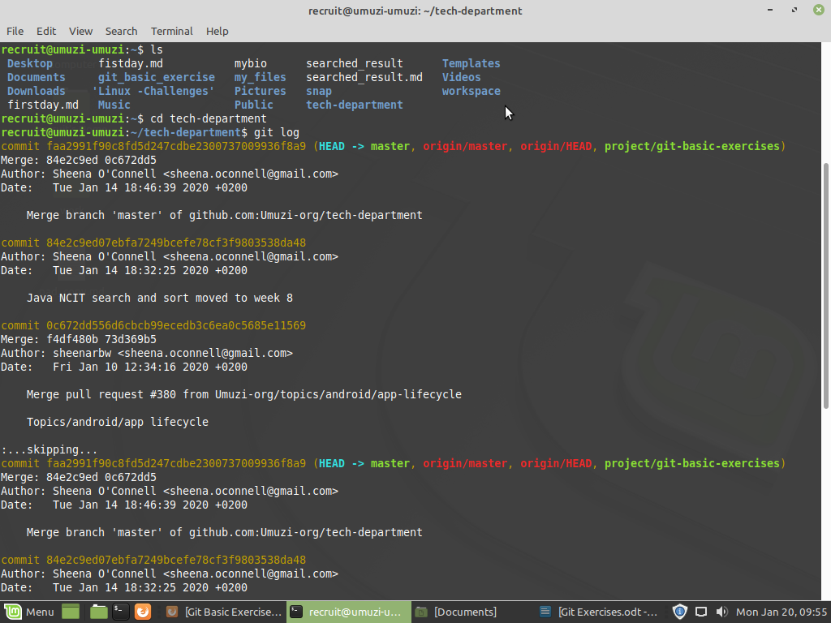
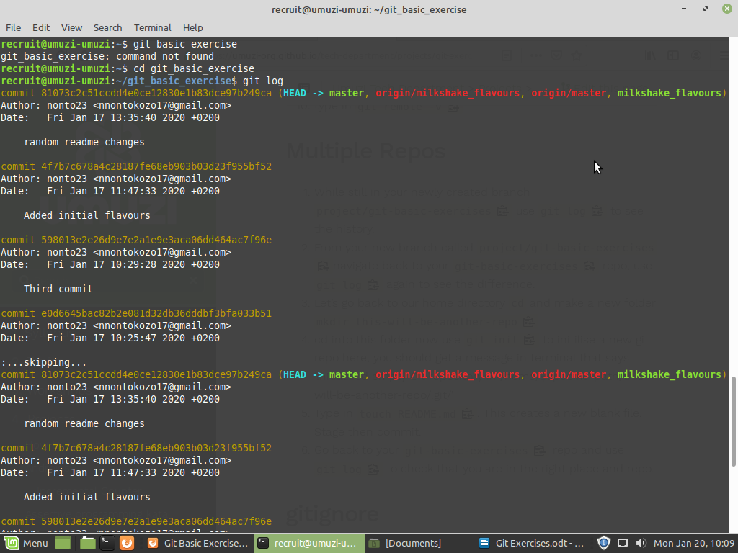

2 git log Ercesice

3 recruit@umuzi-umuzi:~$ mkdir this-will-be-another-repo
4 recruit@umuzi-umuzi:~$ cd this-will-be-another-repo
recruit@umuzi-umuzi:~/this-will-be-another-repo$ git init
Initialized empty Git repository in /home/recruit/this-will-be-another-repo/.git/

5 recruit@umuzi-umuzi:~/this-will-be-another-repo$ touch README.md

6 recruit@umuzi-umuzi:~$ cd git_basic_exercise
recruit@umuzi-umuzi:~/git_basic_exercise$ git log
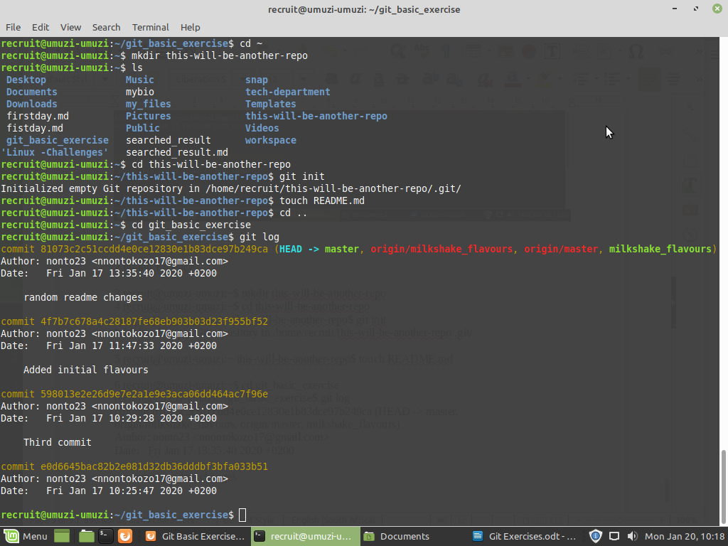
Gitignore

1 recruit@umuzi-umuzi:~/git_basic_exercise$ touch ignore-me.db
2 recruit@umuzi-umuzi:~/git_basic_exercise$ git status
3 recruit@umuzi-umuzi:~/git_basic_exercise$ nano .gitignore
4

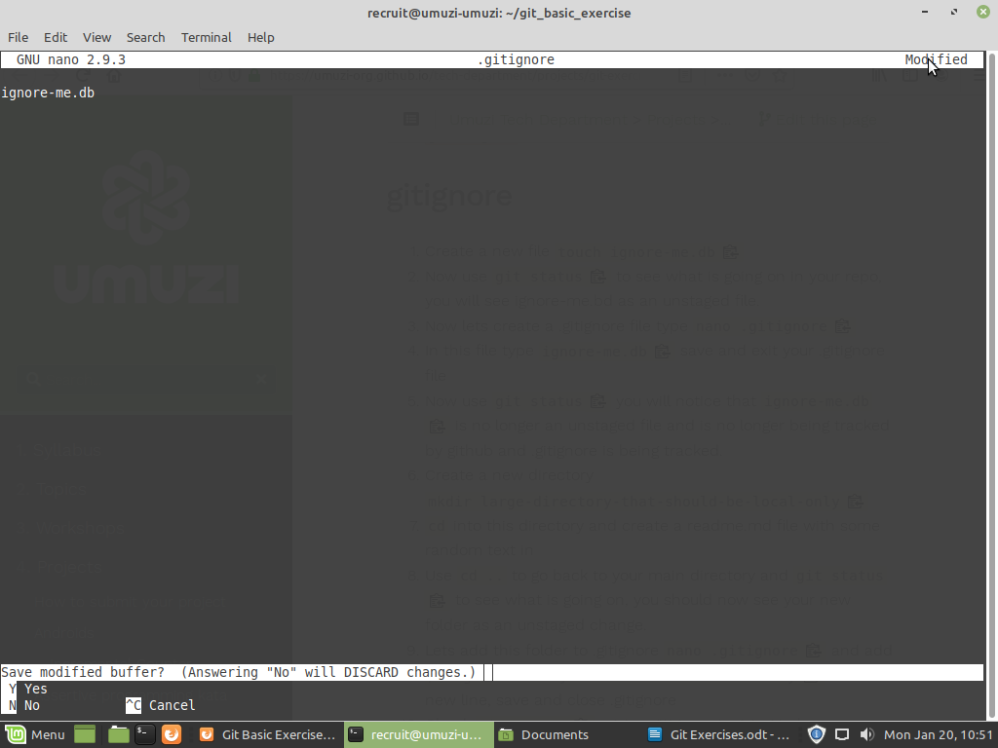
5
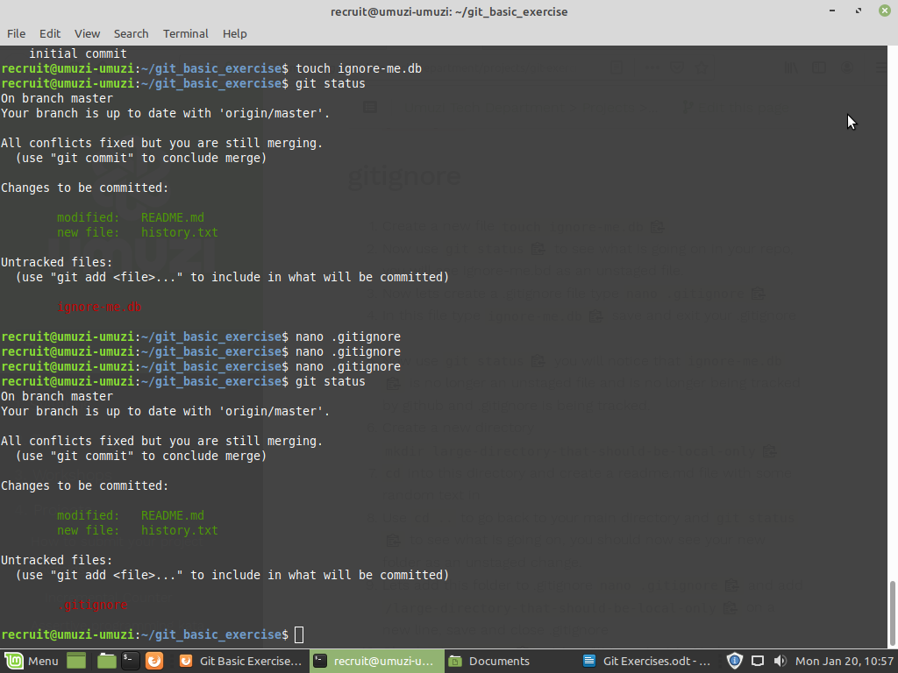

6 recruit@umuzi-umuzi:~/git_basic_exercise$ mkdir large-directory-that-should-be-local-only
7 recruit@umuzi-umuzi:~/git_basic_exercise/large-directory-that-should-be-local-only$ cat > readme.md
Monday is tough
while january is extremely long

8
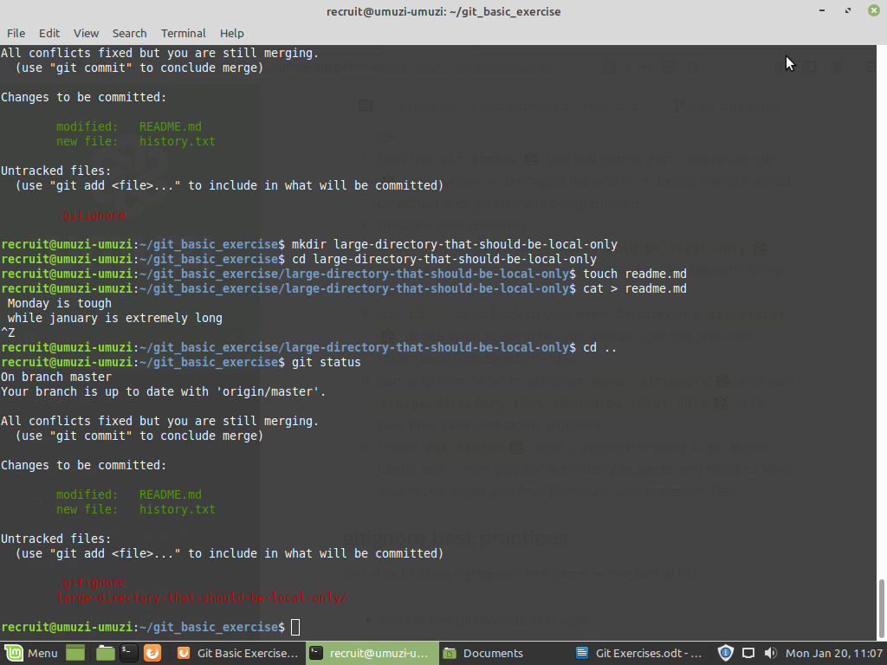
9 recruit@umuzi-umuzi:~/git_basic_exercise$ nano .gitignore

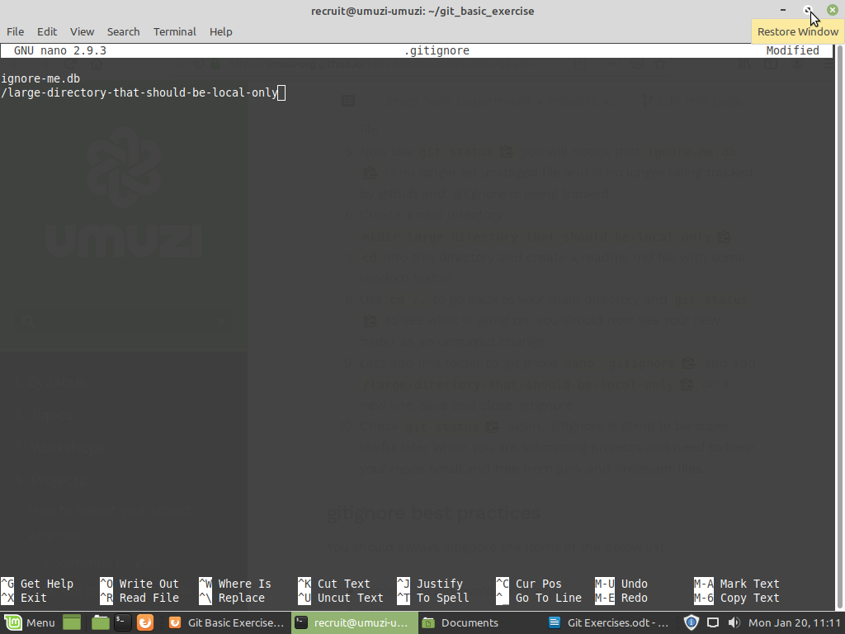

10 recruit@umuzi-umuzi:~/git_basic_exercise$ git status

